**LAC_SUB**

ALS optimization results: (concentration and spectra)

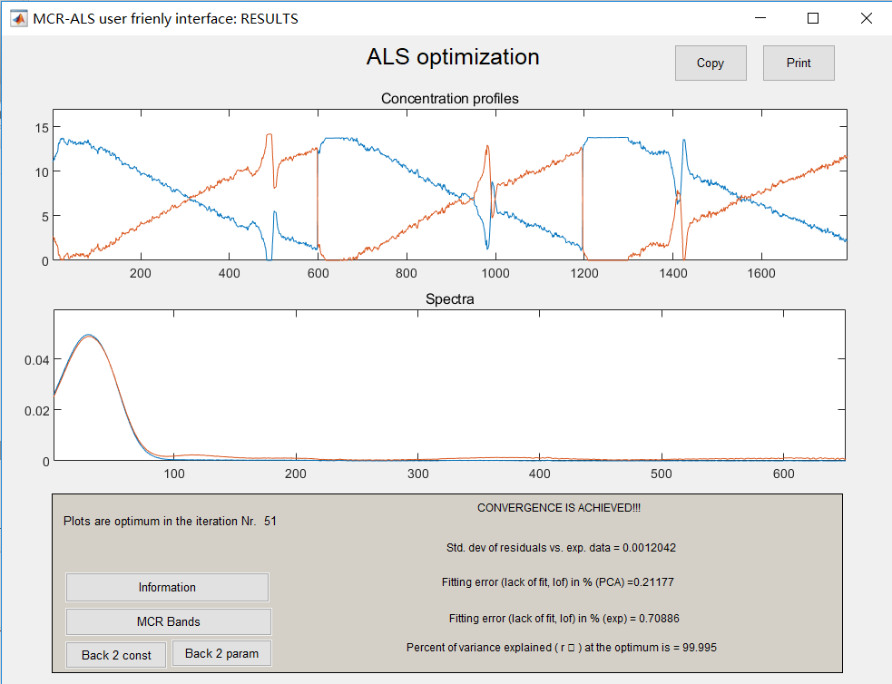

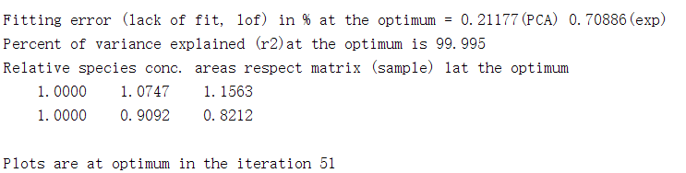

Plot:

1. Concentration plot

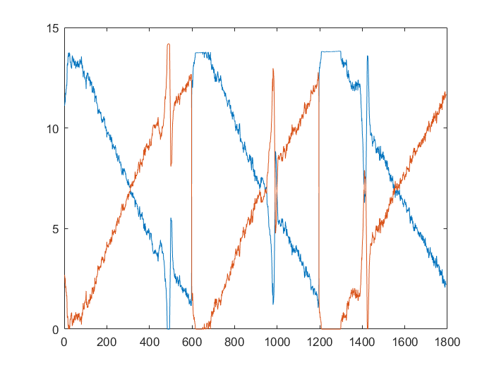

2. Spectra plot (after transposition)

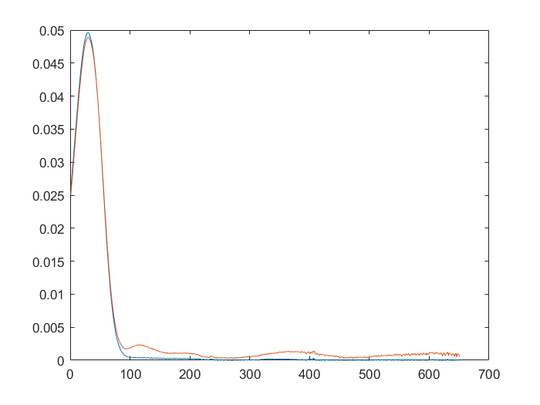

3. Residuals plot

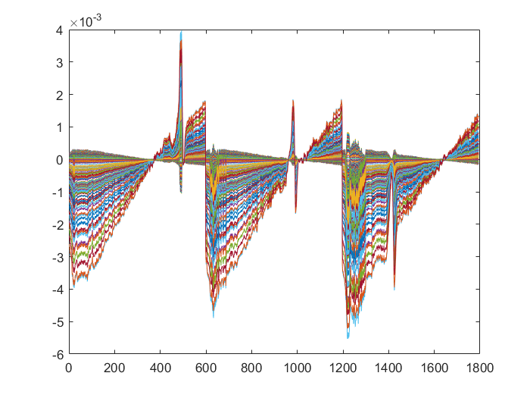

**LAC_SUB_TEMPO**

ALS optimization results: (concentration and spectra)

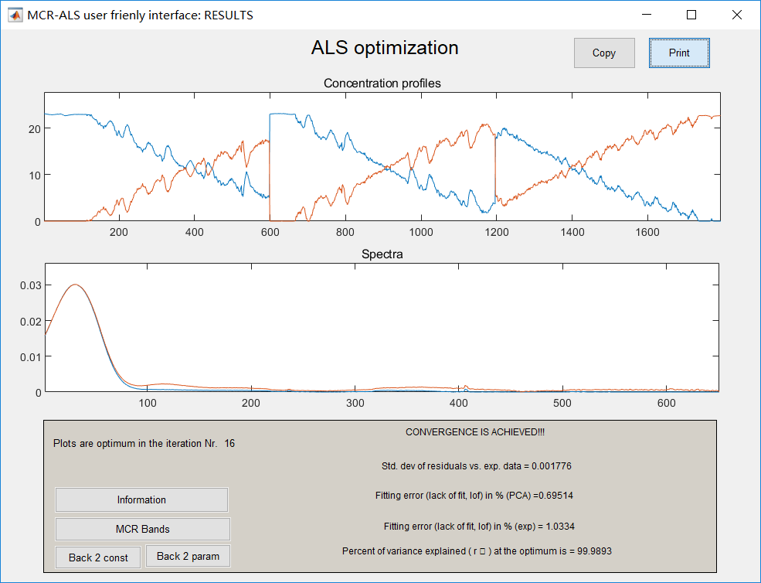

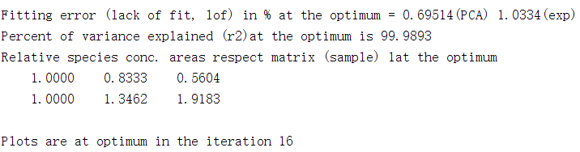

Plot:

1. Concentration plot

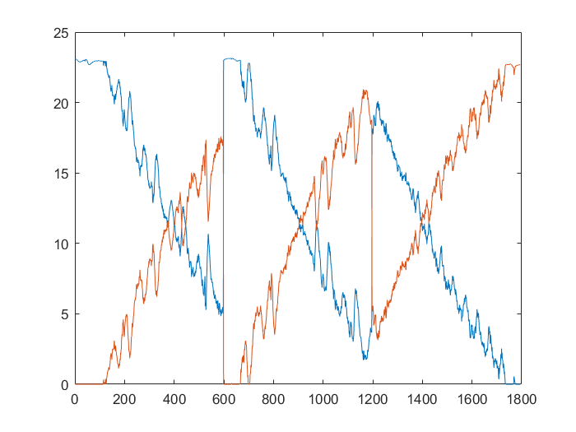

2. Spectra plot (after transposition)

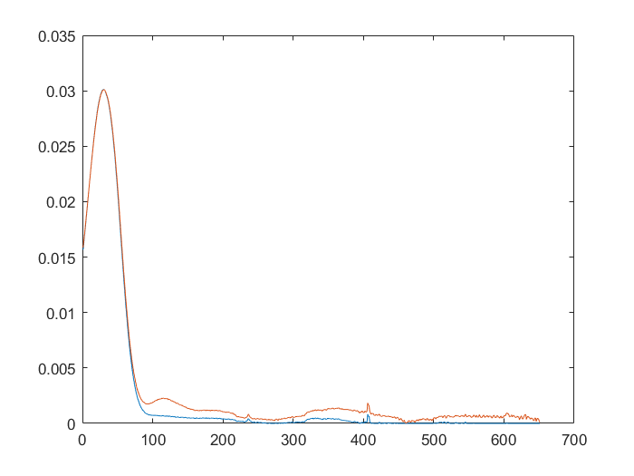

3. Residuals plot

